**Sportifry**

**UI Prototype**

**Version 1.0**

**Revision History**

| **Date** | **Version** | **Description** | **Author** |
| --- | --- | --- | --- |
| 08/12/2021 | 1.0 | UI design for the website, details, position, characteristics of the elements included in the website based on reference, learn about UX, UI | All members |
|  |  |  |  |
|  |  |  |  |
|  |  |  |  |

**Table of Contents**

**Introduction:** **4**

**Guest (Non-user)** **4**

**User** **6**

**Admin** **9**

**Musician** **13**

**UI Prototype**

# Introduction:

This document will simulate the Sportifry web software interface, the programmer relies on this interface design to build the website interface.

# Guest (Non-user)

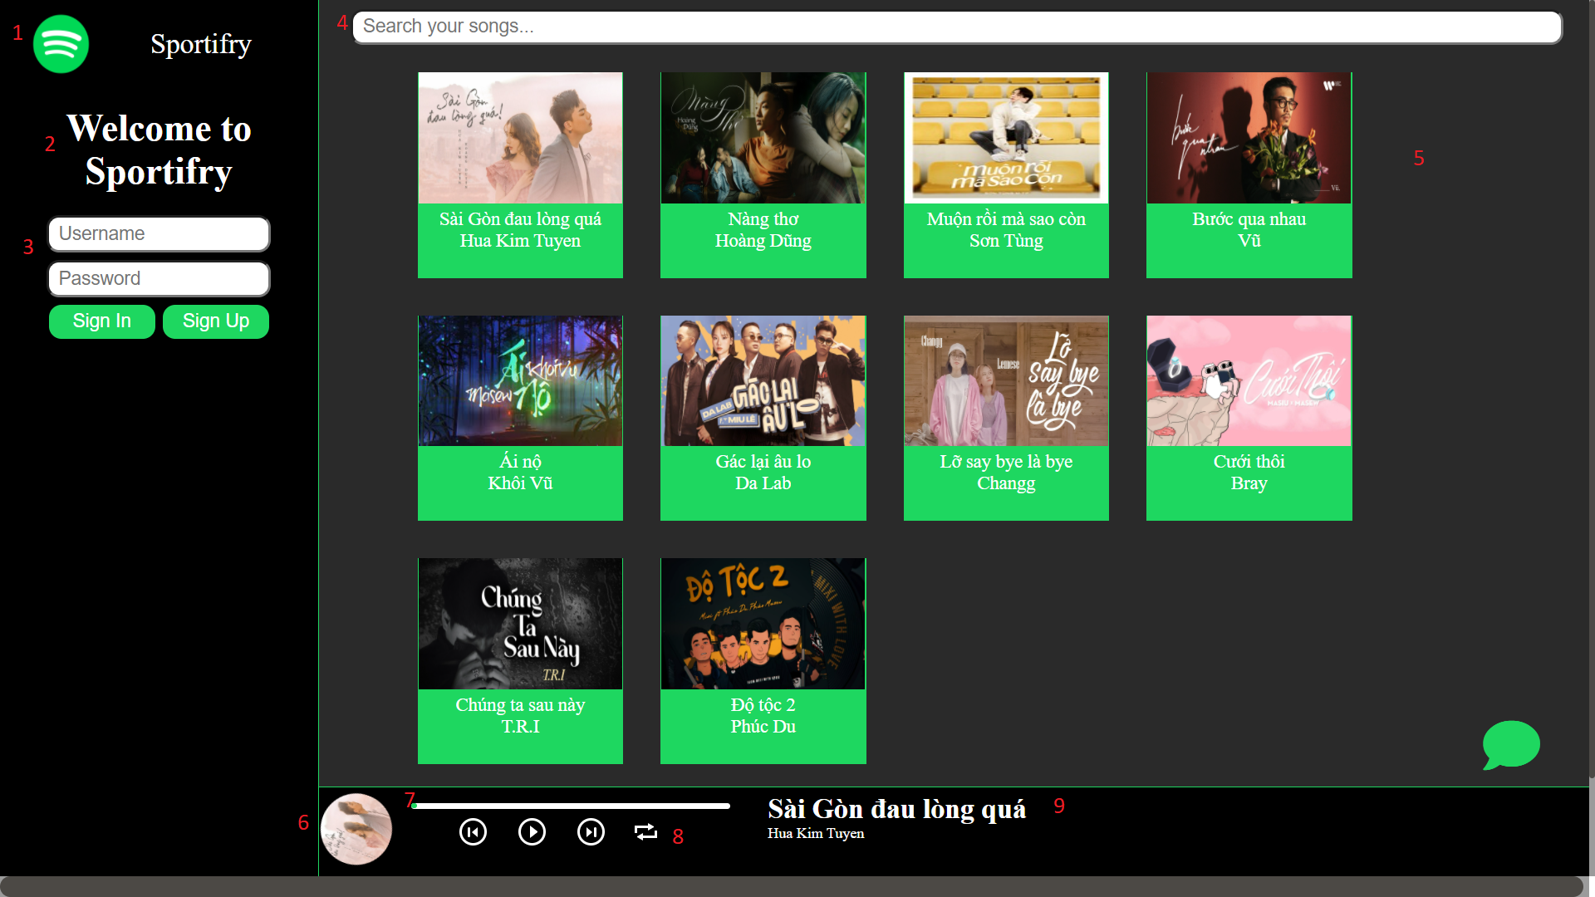

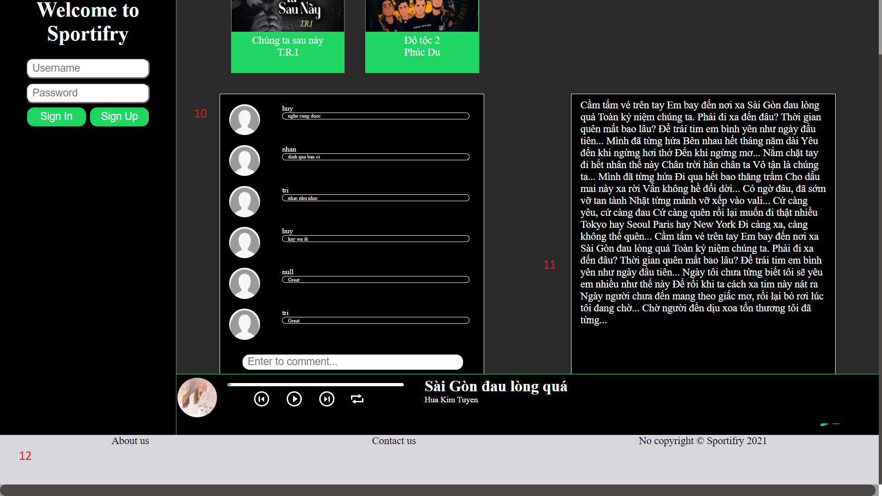

Objects and related functions:

1. Logo
2. Navigation:

For non-user, you only can listen to music

1. Sign in:

Enter your username and password, if you don't have an account, press register otherwise press login if you have an account

1. Search

You can type some words to find your song

1. Song list: Default is our song list. When you search for something, it is your result.
2. Disk track
3. Slider:

It is the progress bar of song, you can forward or backward song by slider

1. Song navigation:

You can change volume, play the previous song, play the next song, pause/play, repeat the current song

1. Song information:

It contains the song's name and author.

1. Comment:

You can see people comment.

1. Song lyrics:
2. Footer:

About our information, you can contact us to report issues.

# User

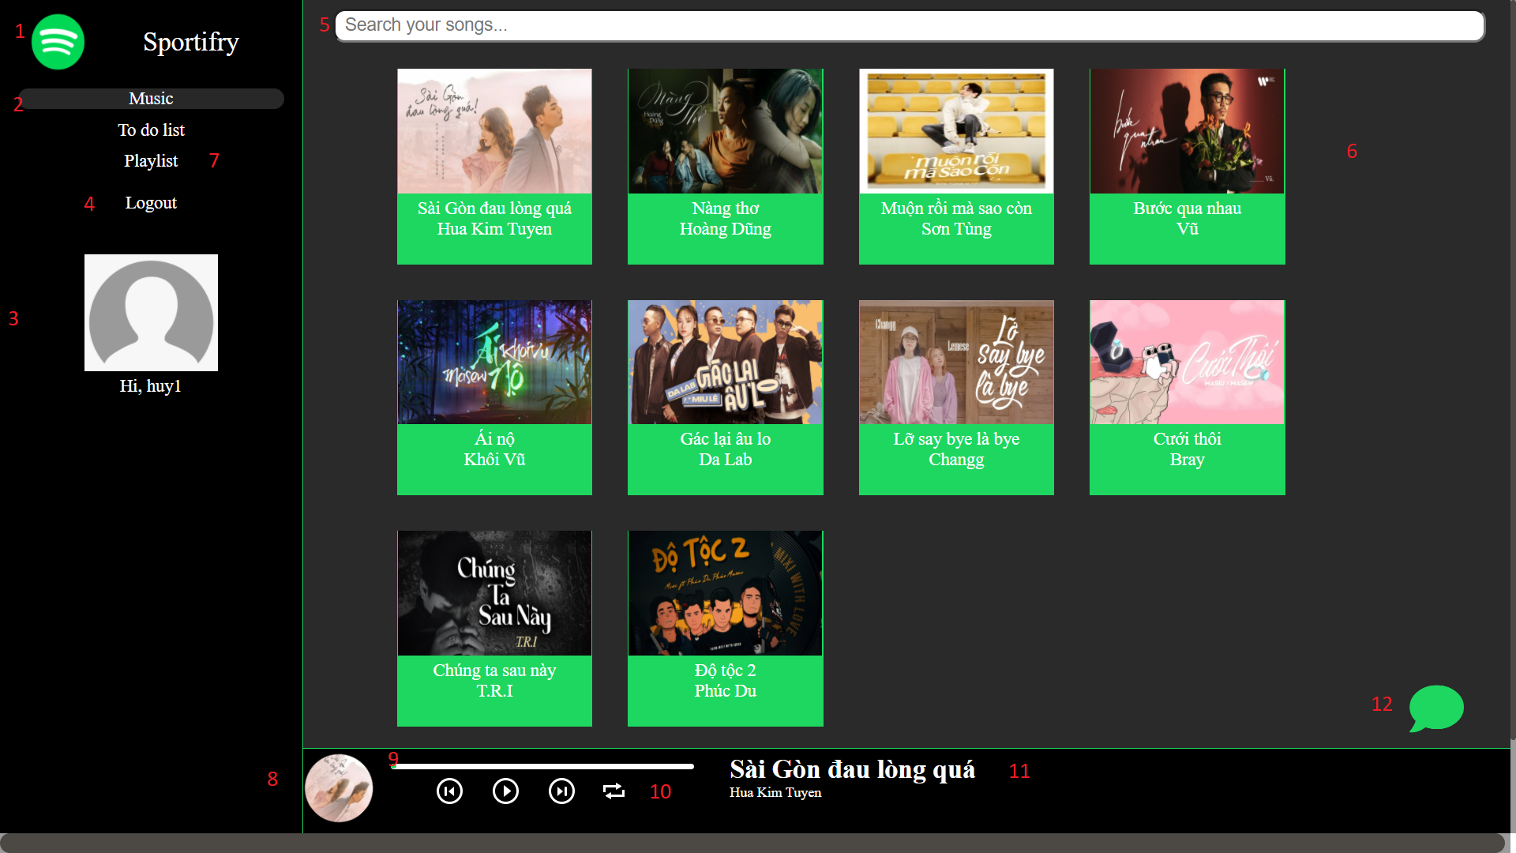

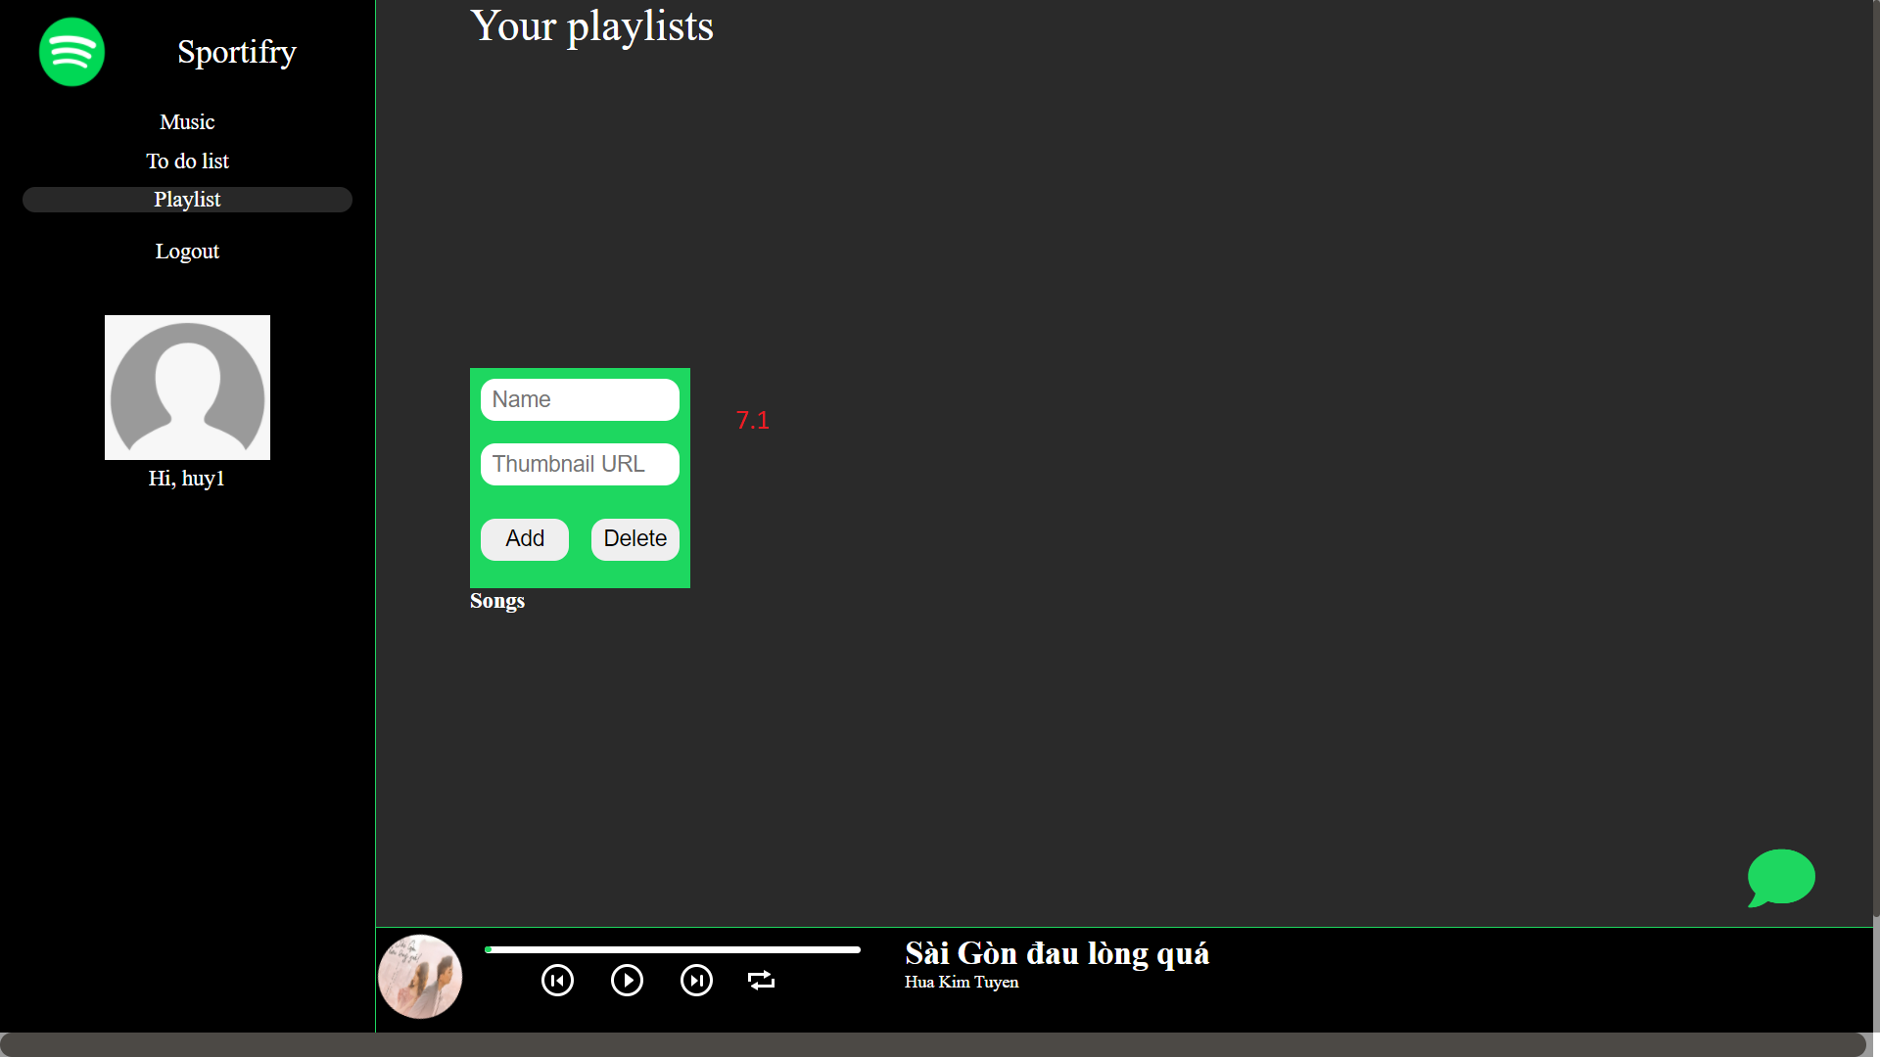

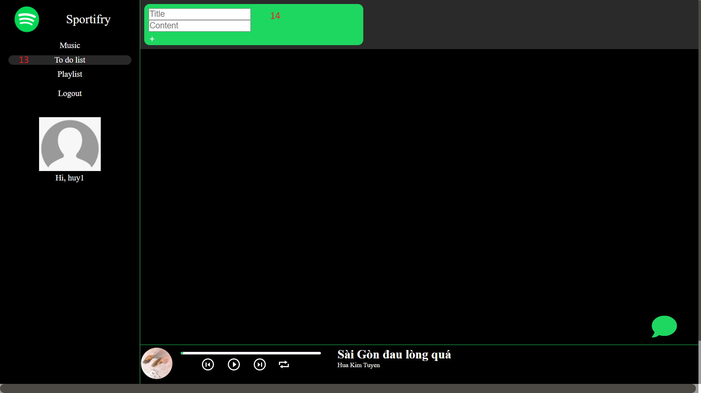

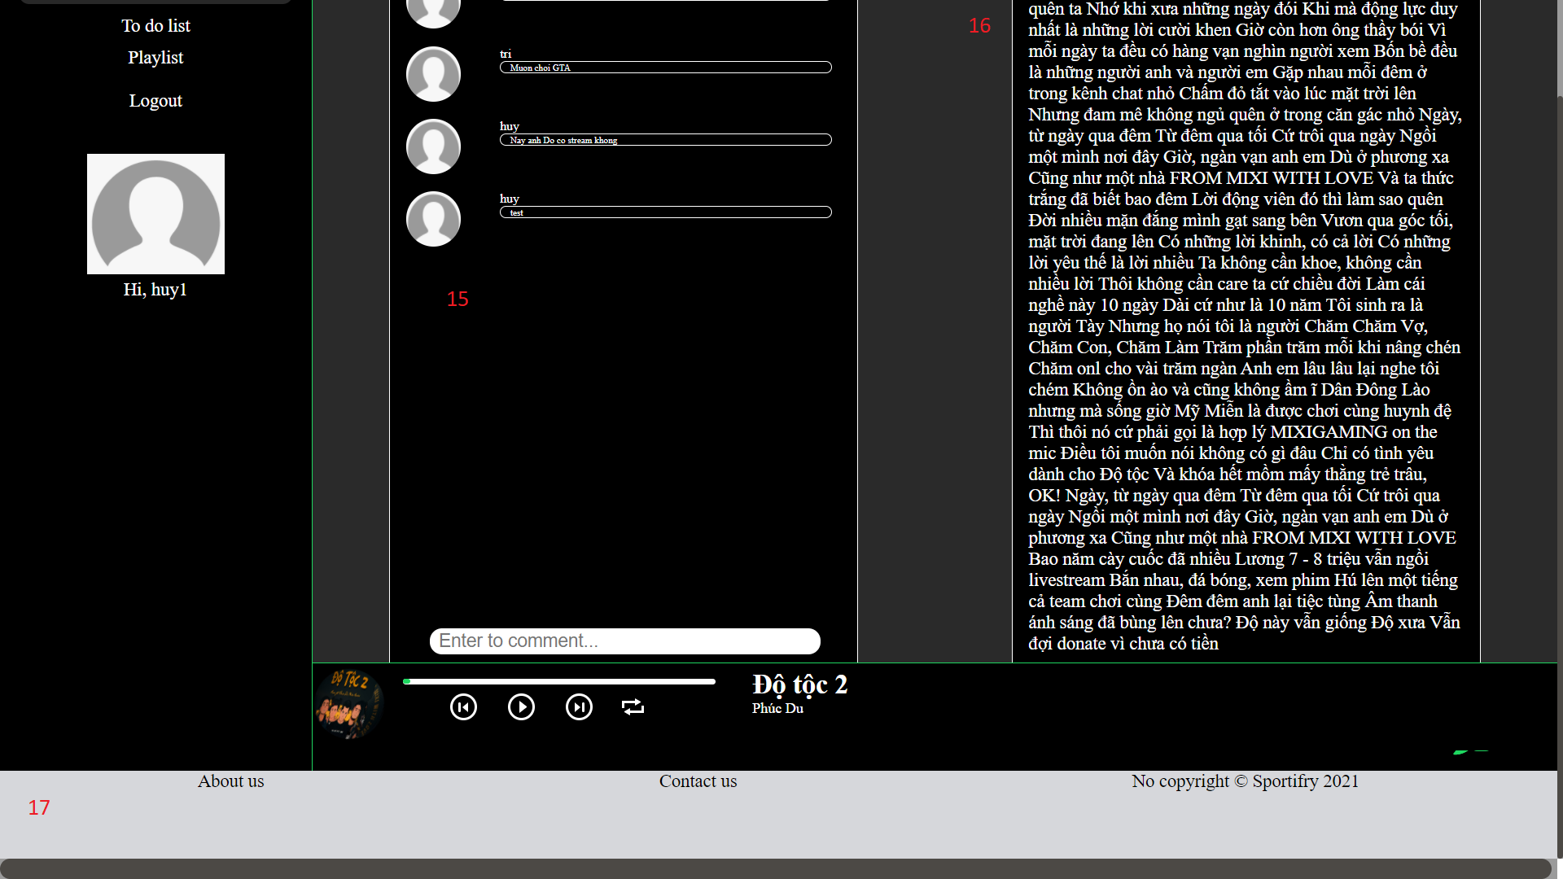

1. Logo
2. Navigation:

With a normal user, you can play music and create to-do list

1. Your information:

It contains your username, avatar

1. Logout
2. Search:

You can type some words to find your song

1. Song list:

Default is our song list. When you search for something, it is your result. You can add a song to a playlist

1. Playlist:

You can create playlist

* 1. Add song to playlist

1. Disk track
2. Slider:

It is the progress bar of song, you can forward or backward song by slider

1. Song navigation:

You can change volume, play the previous song, play the next song, pause/play, repeat the current song

1. Song information:

It contains song name and author.

1. Chat:

You can chat with other users, this is the public channel.

1. To-do-lists:

It allows the user to view, edit, delete saved To-do lists.

1. Create new To-do list:

After users choose the To-do-list tab in navigation, the users can create a new to-do list by filling title, content, then click ‘+’ to save that to-do list.

1. Comment:

You can see people comment.

1. Song lyrics
2. Footer:

About our information, you can contact us to report issues.

# Admin

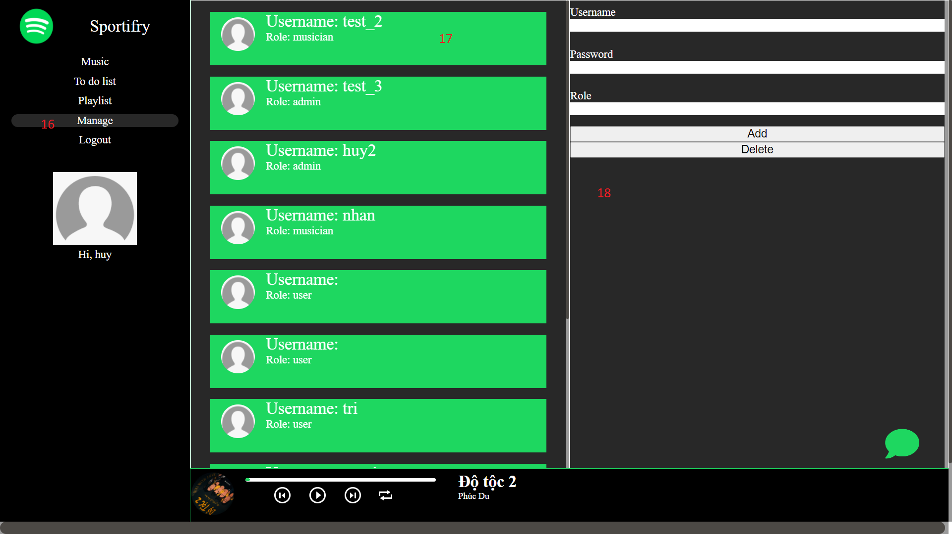

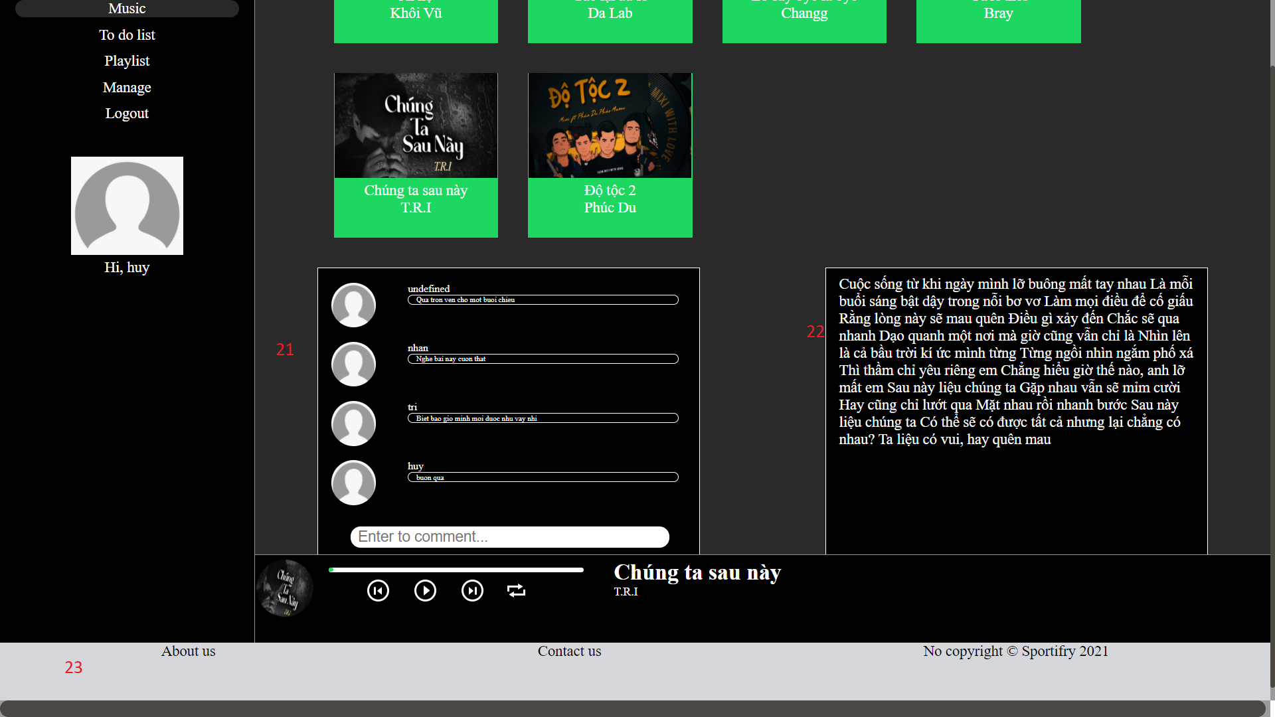

1. Logo
2. Navigation:

With a normal user, you can play music and create to-do list

1. Your information:

It contains your username, avatar

1. Logout
2. Search:

You can type some words to find your song

1. Song list:

Default is our song list. When you search for something, it is your result. You can add a song to a playlist

1. Playlist:

You can create playlist

* 1. Add song to playlist

1. Disk track
2. Slider:

It is the progress bar of song, you can forward or backward song by slider

1. Song navigation:

You can change volume, play the previous song, play the next song, pause/play, repeat the current song

1. Song information:

It contains song name and author.

1. Chat:

You can chat with other users, this is the public channel.

1. To-do-lists:

It allows the user to view, edit, delete saved To-do lists.

1. Create new To-do list:

After users choose the To-do-list tab in navigation, the users can create a new to-do list by filling title, content, then click ‘+’ to save that to-do list.

1. Comment:

You can see people comment.

1. Manage
2. Account list:

Default is our account list.

1. Edit account:

You can add, remove, edit an account to an account list.

19. Song list:

Default is our song list.

20. Edit song:

You can add, remove, edit a song to a song list.

21. Comment:

You can see people comment.

22. Song lyrics

23. Footer:

About our information, you can contact us to report issues.

# Musician

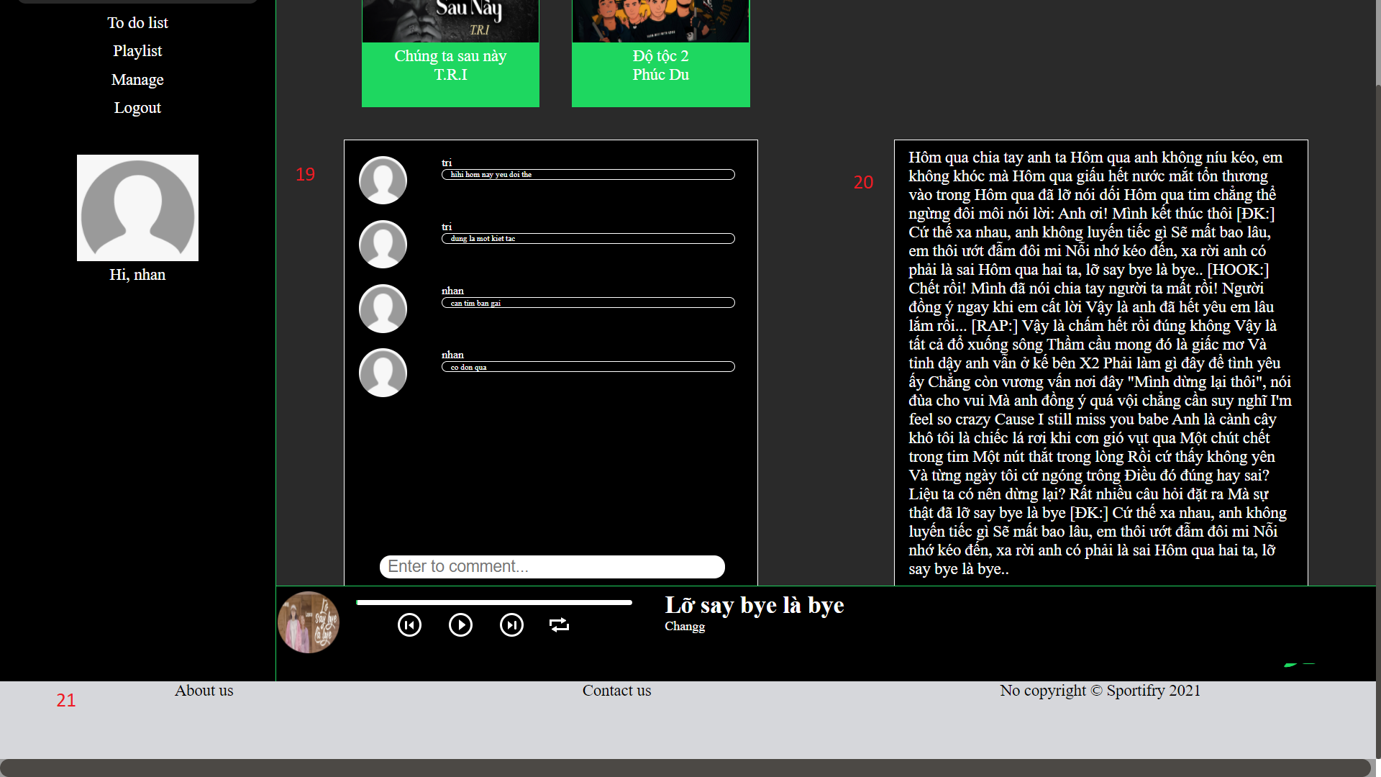

1. Logo
2. Navigation:

With a normal user, you can play music and create to-do list

1. Your information:

It contains your username, avatar

1. Logout
2. Search:

You can type some words to find your song

1. Song list:

Default is our song list. When you search for something, it is your result. You can add a song to a playlist

1. Playlist:

You can create playlist

* 1. Add song to playlist

1. Disk track
2. Slider:

It is the progress bar of song, you can forward or backward song by slider

1. Song navigation:

You can change volume, play the previous song, play the next song, pause/play, repeat the current song

1. Song information:

It contains song name and author.

1. Chat:

You can chat with other users, this is the public channel.

1. To-do-lists:

It allows the user to view, edit, delete saved To-do lists.

1. Create new To-do list:

After users choose the To-do-list tab in navigation, the users can create a new to-do list by filling title, content, then click ‘+’ to save that to-do list.

1. Comment:

You can see people comment.

1. Manage
2. Song list:

Default is our song list.

1. Edit song:

You can add, remove, edit a song to a song list.

1. Comment:

You can see people comment

1. Song lyrics
2. Footer:

About our information, you can contact us to report issues.